Babbly - Project Report

1. INTRODUCTION

1.1 Project Overview
Babbly is a modern social media web application inspired by the X platform (formerly Twitter). It allows users to interact through posts, follow relationships, and receive real-time notifications. The application is designed to be responsive, scalable, and user-friendly.

1.2 Purpose
The goal of Babbly is to provide users with a platform to share their thoughts in the form of posts, interact with others through likes/comments, follow other users, and receive notifications in real time.

2. IDEATION PHASE

2.1 Brainstorm & Idea Prioritization
Step | Description
Step-1: Team Gathering, Collaboration and Select the Problem Statement | The team collaborated to define the problem statement: "How might we provide users with a platform to share their thoughts, interact with others, and receive real-time notifications in a user-friendly way?"
Step-2: Brainstorm, Idea Listing and Grouping | The team brainstormed features including User Authentication, Post Management, Follow System, Admin Controls, Profile Management, Real-Time Notifications, Responsive Design, Image Uploads, and Cloud-Based Storage.
Step-3: Idea Prioritization | The team prioritized features based on importance and feasibility, focusing on core functionalities for Phase 1.

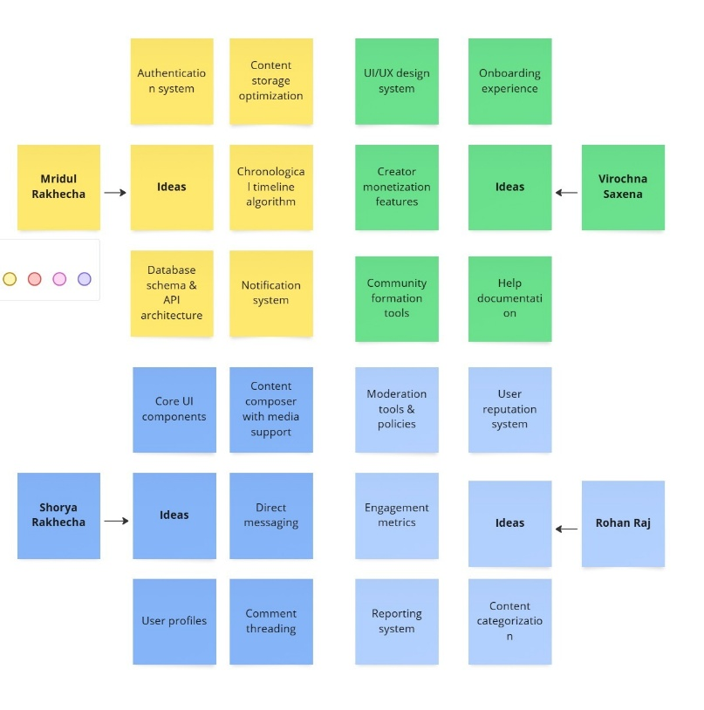

2.2 Define the Problem Statements
Customer Problem Statement:
I am a user trying to share my thoughts and connect with others, but it is hard to find a platform that is user-friendly, provides real-time interactions, and has the features I need, which makes me feel frustrated and disconnected.
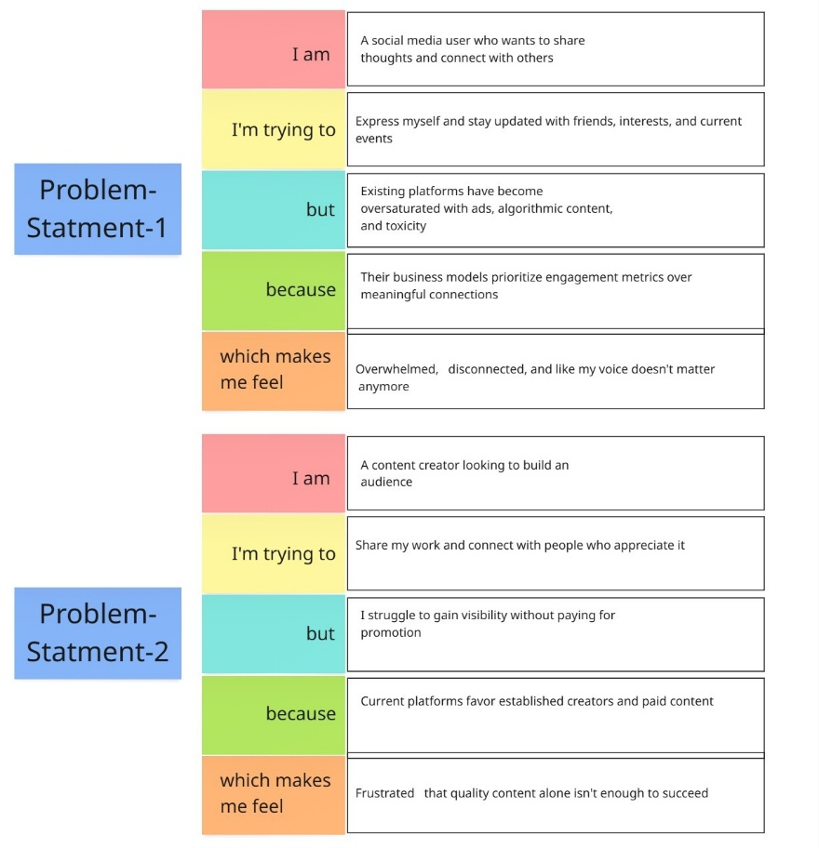

2.3 Empathize & Discover
What does he THINK AND FEEL?
- Wants a user-friendly platform
- Values real-time interaction
- Needs to feel connected
- Aspirations for easy sharing
What does he HEAR?
- Hears about other social media platforms
- Sees ads promoting connectivity
- Hears friends talking about user experience
What does he SAY AND DO?
- Shares thoughts and updates
- Connects with other users
- Looks for easy-to-use interfaces
What does he SEE?
- Sees posts and updates from others
- Sees profiles and notifications
- Sees different social media layouts
Pain
- Frustration with complex interfaces
- Difficulty in finding relevant content
- Feeling disconnected
Gain
- Wants a platform for easy sharing
- Needs real-time interaction
- Desires a sense of community

3.What does he SAY AND DO?
Shares thoughts and updates
Connects with other users
Looks for easy-to-use interfaces

2.What does he HEAR?
Hears about other social media platforms
Sees ads promoting connectivity
Hears friends talking about user experience

5.Gain
Wants a platform for easy sharing
Needs real-time interaction
Desires a sense of community

5.Pain
Frustration with complex interfaces
Difficulty in finding relevant content
Feeling disconnected

4.What does he SEE?
Sees posts and updates from others
Sees profiles and notifications
Sees different social media layouts

USER
1.What does he THINK AND FEEL?
Wants a user-friendly platform
Values real-time interaction
Needs to feel connected
Aspirations for easy sharing

3. REQUIREMENT ANALYSIS

Table 1: Components & Technologies
S.No. | Component | Description | Technology
1. | User Interface | Web-based responsive UI | React.js, Tailwind CSS, DaisyUI.
2. | Application Logic-1 | Authentication & Authorization | Node.js, Express.js, JWT
3. | Application Logic-2 | Real-time Notifications | Socket.io
4. | Application Logic-3 | Post/Follow Management | Express.js REST APIs
5. | Database | User/Post/Follow Data | MongoDB (NoSQL)
6. | Cloud Database | Hosted Database Service | MongoDB Atlas
7. | File Storage | Image/Media Uploads | Cloudinary
8. | External API-1 | Authentication (OAuth 2.0) | Google/Facebook API (Future)
9. | External API-2 | Analytics (Future) | N/A
10. | Machine Learning Model | Content Recommendation (Future) | N/A
11. | Infrastructure (Server / Cloud) | Cloud Deployment | AWS EC2, Vercel (Frontend)

Table 2: Application Characteristics
S.No. | Characteristics | Description | Technology
1. | Open-Source Frameworks | Frontend & Backend Libraries | React, Express, Mongoose
2. | Security Implementations | JWT Encryption, Rate Limiting | SHA-256, OWASP Top 10
3. | Scalable Architecture | Microservices-ready (Future) | Kubernetes (Future)
4. | Availability | Load-balanced APIs, DB Replication | MongoDB Atlas, AWS ALB
5. | Performance | Caching, CDN for Media | Redis (Future), Cloudinary CDN

3.1 Architecture Diagram
- CONTEXT DIAGRAM:
- CONTAINERS DIAGRAM:
- COMPONENT DIAGRAM (BACKEND FOCUS):

Data Flow Diagrams:
A Data Flow Diagram (DFD) is a traditional visual representation of the information flows within a system. A neat and clear DFD can depict the right amount of the system requirement graphically. It shows how data enters and leaves the system, what changes the information, and where data is stored. Example: DFD Level 0 (Industry Standard)

3.2 User Stories
Use the below template to list all the user stories for the product.
User Type | Functional Requirement (Epic) | User Story Number | User Story / Task | Acceptance criteria | Priority | Release
End User | Authentication | US-01 | As a user, I can register via email/password. | Account created; confirmation email sent. | High | Sprint-1
 |  | US-02 | As a user, I can log in securely with JWT. | Token generated; dashboard accessible. | High | Sprint-1
 | Post Management | US-03 | As a user, I can create posts with text/images (≤5MB). | Post appears in feed; image stored in Cloudinary. | High | Sprint-1
 |  | US-04 | As a user, I can like/comment on posts. | Like count updates; comment saved in DB. | Medium | Sprint-2
 | Follow System | US-05 | As a user, I can follow/unfollow others. | Follow list updates; feed refreshes. | High | Sprint-2
 | Notifications | US-06 | As a user, I get real-time alerts for interactions. | Notifications appear via Socket.io. | Medium | Sprint-3
Admin | Moderation | US-07 | As an admin, I can delete any post. | Post removed from DB/UI. | Low | Sprint-3

3.3 Functional Requirements
Following are the functional requirements of the proposed solution.
FR No. | Functional Requirement (Epic) | Sub Requirement (Story / Sub-Task)
FR-1 | User Authentication | - Registration through email/password- Login/Logout with JWT- Password reset flow
FR-2 | Post Management | - Create/delete text posts- Upload images (Cloudinary)- Like/comment on posts
FR-3 | Follow System | - Follow/unfollow users- Personalized feed based on follows
FR-4 | Real-Time Notifications | - Alerts for likes/comments (Socket.io)- Follow notifications
FR-5 | Profile Management | - View/edit user profiles- View others' profiles/posts
FR-6 | Admin Controls | - Delete any user’s post- Ban users (future)

3.4 Non-functional Requirements
Following are the non-functional requirements of the proposed solution.
FR No. | Non-Functional Requirement | Description
NFR-1 | Usability | - Mobile-first responsive UI (Tailwind CSS)- Intuitive navigation (React Router)
NFR-2 | Security | - JWT encryption (SHA-256)- Rate limiting for APIs- OWASP compliance
NFR-3 | Reliability | - 99.9% uptime (MongoDB Atlas)- Automated backups
NFR-4 | Performance | - API response <500ms under load- Image CDN (Cloudinary)
NFR-5 | Availability | - Load-balanced APIs (AWS)- DB replication (MongoDB Atlas)
NFR-6 | Scalability | - Microservices-ready (future Kubernetes)- Redis caching (future)

4. PROJECT DESIGN

4.1 Problem - Solution Fit
Parameter | Description
1. CUSTOMER SEGMENT(S) (CS) | Users seeking a social media platform to share thoughts, interact, and receive real-time updates.
2. JOBS-TO-BE-DONE PROBLEMS | Difficulty finding a user-friendly platform with real-time interaction and desired features.
PROBLEM ROOT CAUSE (RC) | Lack of platforms that effectively combine user-friendly design, real-time updates, and essential social media features.
3. TRIGGERS (TR) | Desire to share thoughts, connect with others, stay updated, and need for a responsive and scalable platform.
4. EMOTIONS BEFORE/AFTER (EM) | Frustration/disconnection before; satisfaction/connectedness after using Babbly.
5. AVAILABLE SOLUTIONS (AS) | Existing social media platforms (X, etc.).
6. CUSTOMER CONSTRAINTS (CC) | Need for ease of use, responsiveness, scalability, and essential features.
7. BEHAVIOUR | Users currently use other social media but seek better alternatives.
8. YOUR SOLUTION (SL) | Babbly: A social media web application with user authentication, post management, follow system, real-time notifications, responsive design, etc.
CHANNELS of BEHAVIOUR (CH) | Web browsers, mobile devices.

4.2 Proposed Solution
S.No. | Parameter | Description
1. | Problem Statement (Problem to be solved) | Users need a user-friendly social media platform with real-time interaction and essential features.
2. | Idea / Solution description | Babbly is a web application with features like user authentication, post management, follow system, real-time notifications, responsive design.
3. | Novelty / Uniqueness | Combines essential social media features with a focus on user-friendliness, responsiveness, and real-time updates.
4. | Social Impact / Customer Satisfaction | Provides a platform for users to connect, share, and stay updated, enhancing social interaction and satisfaction.
5. | Business Model (Revenue Model) | *To be determined (e.g., advertising, premium features).
6. | Scalability of the Solution | Designed to be scalable using technologies like MongoDB Atlas and React.js.

4.3 Solution Architecture
The solution architecture of Babbly is designed to bridge the gap between the need for a social media platform and the technology required to build it.
Key components include:
- Frontend: React.js with Vite for fast builds, Tailwind CSS, and DaisyUI for styling and consistent design.
- Backend: Node.js with Express.js for RESTful API development.
- Database: MongoDB Atlas for scalable cloud storage.
- Authentication: JWT-based authentication system with token validation middleware.
The architecture supports features like user authentication, post management, follow system, and real-time notifications.

5. PROJECT PLANNING & SCHEDULING

5.1 Product Backlog, Sprint Schedule, and Estimation
Sprint | Functional Requirement (Epic) | User Story Number | User Story / Task | Story Points | Priority | Team Members
Sprint-1 | User Authentication | USN-1 | As a user, I can register for the application by entering my email, password, and confirming my password. | 2 | High | Shorya Rakhecha, Virochna Saxena
Sprint-1 | User Authentication | USN-2 | As a user, I will receive a confirmation email once I have registered for the application. | 1 | High | Virochna Saxena
Sprint-1 | User Authentication | USN-5 | As a user, I can log into the application by entering email & password. | 1 | High | Shorya Rakhecha
Sprint-1 | Post Management | USN-6 | As a user, I can create a new post. | 2 | High | Shorya Rakhecha
Sprint-1 | Post Management | USN-7 | As a user, I can view posts from other users. | 1 | High | Shorya Rakhecha
Sprint-1 | Follow System | USN-10 | As a user, I can follow other users. | 2 | Medium | Rohan Raj
Sprint-1 | Follow System | USN-11 | As a user, I can unfollow other users. | 1 | Medium | Rohan Raj
Sprint-1 | User Interface | USN-15 | Design the Home Page. | 3 | High | Shorya Rakhecha
Sprint-1 | User Interface | USN-16 | Design the User Profile Page. | 2 | Medium | Shorya Rakhecha
Sprint-2 | User Authentication | USN-3 | As a user, I can register for the application through Facebook. | 2 | Low | Virochna Saxena
Sprint-2 | User Authentication | USN-4 | As a user, I can register for the application through Gmail. | 2 | Medium | Virochna Saxena
Sprint-2 | Post Management | USN-8 | As a user, I can like/unlike a post. | 2 | Medium | Shorya Rakhecha
Sprint-2 | Post Management | USN-9 | As a user, I can add a comment to a post. | 3 | Medium | Shorya Rakhecha
Sprint-2 | Real-Time Notifications | USN-12 | As a user, I can receive notifications for likes on my posts. | 2 | High | Virochna Saxena, Rohan Raj
Sprint-2 | Real-Time Notifications | USN-13 | As a user, I can receive notifications for comments on my posts. | 2 | High | Virochna Saxena, Rohan Raj
Sprint-2 | Real-Time Notifications | USN-14 | As a user, I can receive notifications for new followers. | 2 | Medium | Virochna Saxena, Rohan Raj
Sprint-2 | User Interface | USN-17 | Design the Notifications Page. | 3 | Medium | Shorya Rakhecha

5.2 Project Tracker, Velocity & Burndown Chart
Sprint | Total Story Points | Duration | Sprint Start Date | Sprint End Date (Planned) | Story Points Completed (as on Planned End Date) | Sprint Release Date (Actual)
Sprint-1 | 16 | 5 Days | 01 April 2025 | 05 April 2025 | 16 | 05 April 2025
Sprint-2 | 18 | 5 Days | 08 April 2025 | 12 April 2025 | 18 | 12 April 2025
Sprint-3 | *To be determined* | 5 Days | 15 April 2025 | 19 April 2025 | *To be determined* | *To be determined*
Sprint-4 | *To be determined* | 5 Days | 22 April 2025 | 26 April 2025 | *To be determined* | *To be determined*
Velocity:
Sprint 1 Velocity = 16 story points
Sprint 2 Velocity = 18 story points
Average Velocity = (16 + 18) / 2 = 17 story points per sprint
The burndown charts visually represent the remaining story points over each sprint's duration.
They help the team track progress and predict whether the sprint goal will be achieved.

6. FUNCTIONAL AND PERFORMANCE TESTING

6.1 Performance Testing
Testing Scope:
- Functional
  - Auth (login/JWT)
  - Posts (create/like/comment)
  - Follow system
  - Real-time notifications
  - Admin controls
- Performance
  - API load testing
  - DB query speed
  - Notification delays
- UI/UX
  - Mobile responsiveness
  - Cross-browser checks
- Security
  - JWT validation
  - Role-based access
- Integration
  - API sync (FE-BE)
  - Cloudinary uploads
- Regression
  - Automated E2E tests
Tools : Postman, Cypress, JMeter Focus : Real-time features, scalability, security.
Testing Environment:
URL/Location: https://github.com/username/babbly.git

Test Cases:
Test Case ID | Test Scenario | Test Steps | Expected Result | Actual Result | Pass/Fail
TC-001 | User Login | 1. Enter valid credentials2. Click "Login" | JWT token generated, user redirected to home. | Token received, redirected successfully | Pass
TC-002 | Create Post | 1. Click "New Post"2. Add text/image3. Submit | Post appears in feed | Post created but image failed to upload (Cloudinary error) | Fail
TC-003 | Like Post | 1. Click like button on a post | Like count increment, notification sent | Like count updated, but no notification sent | Fail
TC-004 | Follow User | 1. Visit profile2. Click "Follow " | User added to following list, feed updates | Follow successful, feed updated in real-time | Pass
TC-005 | Admin Delete Post | 1. Admin logs in2. Delete any post | Post removed globally | Post deleted but still visible to author (cache issue ) | Fail

Bug Tracking:
Bug ID | Bug Description | Steps to reproduce | Severity | Status | Additional feedback
BG-001 | Image upload fails >5MB | 1. Upload large image2. Submit post | High | Open | Add file size validation
BG-002 | Notifications delayed | 1. Like a post2. Observe delay (>3s) | Medium | In Progress | Optimize WebSocket
BG-003 | JWT expiry not enforced | 1. Use expired token2. Access protected route | Critical | Open | Fix token validation

Sign-off:
Tester Name: Rohan Raj
Date: 7th April, 2025
Signature: Rohan Raj
Notes:
- Ensure that all test cases cover both positive and negative scenarios.
- Encourage testers to provide detailed feedback, including any suggestions for improvement.
- Bug tracking should include details such as severity, status, and steps to reproduce.
- Obtain sign-off from both the project manager and product owner before proceeding with deployment.

7. RESULTS

7.1 Output Screenshots
Key screens from the application:
- Authentication: Login and Signup pages
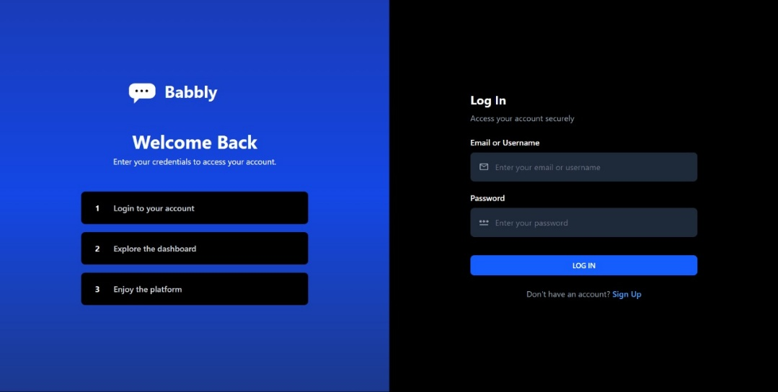
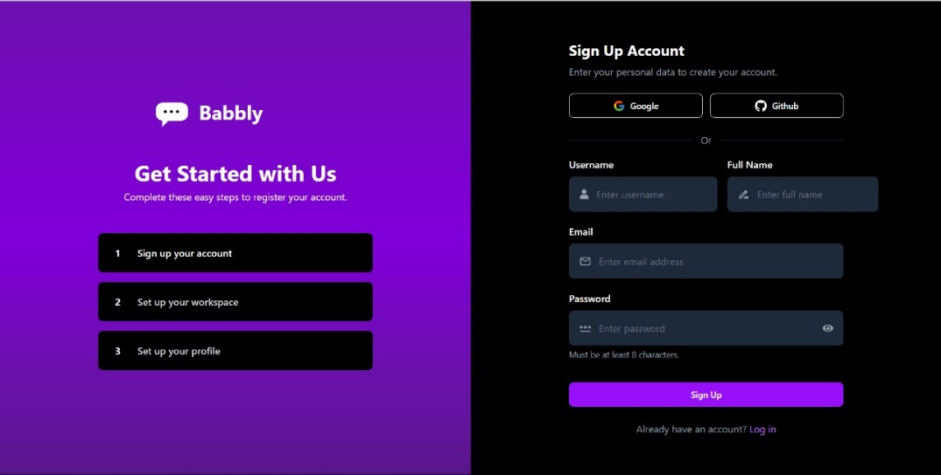
- Home: Feed of posts with create post functionality
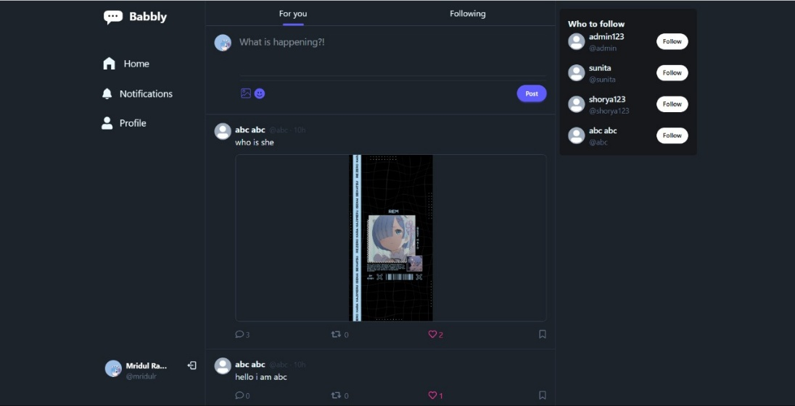
- Profile: User profiles with edit capabilities
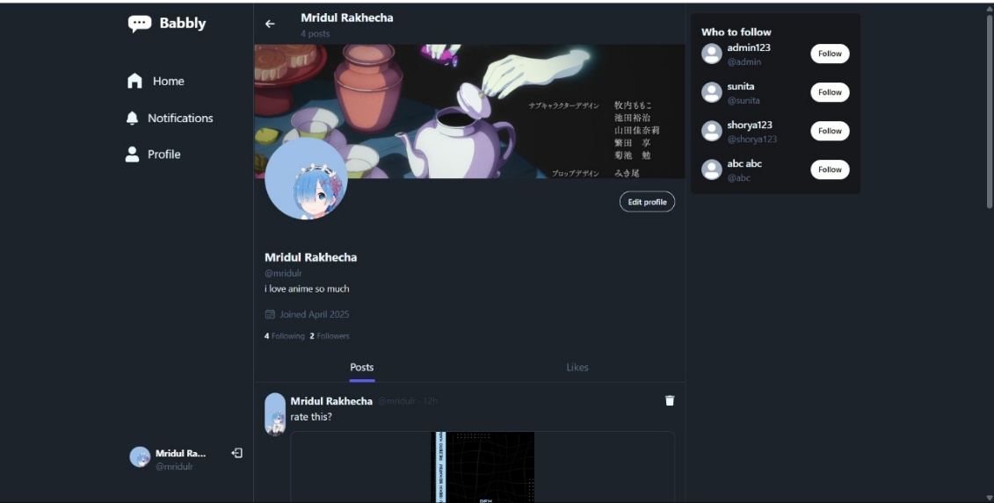
- Notifications: List of user notifications
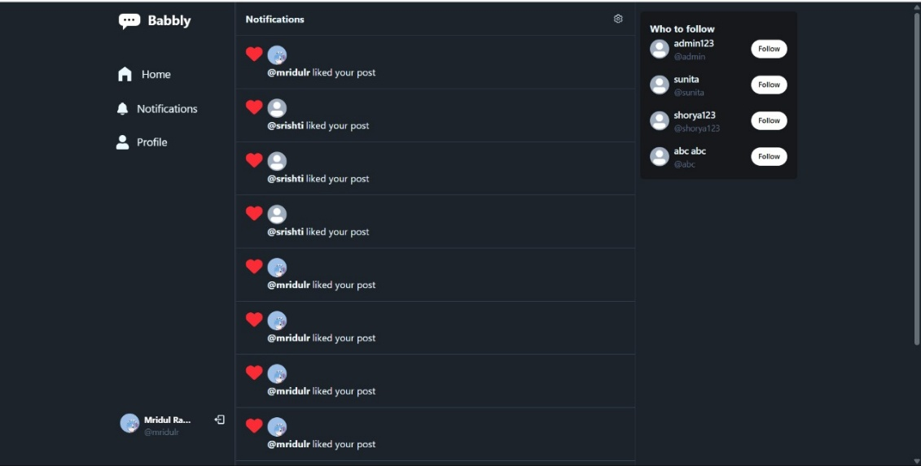
8. ADVANTAGES & DISADVANTAGES
Advantages:
- Modern, responsive user interface.
- Real-time notification system.
- Scalable cloud-based architecture.
- Secure authentication using JWT tokens.
- User-friendly design with mobile-first responsiveness.
- Integration with Cloudinary for seamless image uploads.
Disadvantages:
- Dependency on external services like MongoDB Atlas and Cloudinary may increase costs for scaling.
- Limited moderation tools for administrators; advanced features need further development.
- Performance issues may arise during high traffic due to real-time notification handling.
- Lack of offline functionality; users cannot access data without an internet connection.
- Initial setup requires technical expertise, which may not be user-friendly for non-developers.
9. CONCLUSION
Babbly successfully bridges the gap between user needs for a modern social media platform and technological advancements. By leveraging the MERN stack, it provides a scalable, responsive, and feature-rich application that enhances user interaction and connectivity. While there are areas for improvement, such as advanced moderation tools and offline functionality, Babbly demonstrates strong potential as a competitive social media platform in its current form.
10. FUTURE SCOPE
The future scope of Babbly includes:
- Advanced Moderation Features: Developing tools for administrators to manage user content more effectively.
- Offline Mode: Implementing offline access to posts and notifications for better usability in low-connectivity areas.
- AI-Powered Recommendations: Integrating machine learning algorithms to provide personalized post recommendations based on user behavior.
- Enhanced Security Measures: Adding two-factor authentication and advanced encryption techniques to improve user data security.
- Globalization: Supporting multiple languages to cater to a global audience.
- Mobile Application Development: Creating native apps for iOS and Android platforms for enhanced performance and accessibility.
11. APPENDIX
Appendix A: Team Members
- Mridul Rakhecha (Team Leader & Backend Developer): Led the team and managed backend development tasks such as server-side logic and API integration.
- Shorya Rakhecha (Frontend & UI Developer): Designed and implemented the user interface, ensuring responsiveness and usability.
- Virochna Saxena (Design & Documentation): Assisted with UI/UX design elements and project documentation preparation.
- Rohan Raj (Design & Documentation): Supported visual design tasks and helped format technical documentation.
Appendix B: Technologies Used
Frontend:
- HTML5, CSS3, JavaScript
- React.js with Vite
Backend:
- Node.js with Express.js
Database:
- MongoDB Atlas
Other Tools:
- Cloudinary for image hosting
Appendix C: Testing Tools
- Postman (API testing)
- Cypress (End-to-End testing)
- JMeter (Performance testing)

